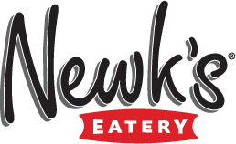
“We Cater… You Party!”

Name: ______________

Sandwich: Note: Each box contains plastic fork knife set and mayo/mustard on the side

Classic Box Lunch
Your choice of Sandwich, Chips, Dessert & Pasta Salad OR Fresh Fruit

Sandwich: (Circle One)
Turkey
Ham
Roast Beef
Chicken Salad
Grilled Chicken (includes Bacon)
Club (includes Bacon)
Vegetarian

Bread on Sandwich: (Circle One)
Wheat berry Croissant

Chips: (Circle One)
Lays Cheetos BBQ Baked
Baked Lays Sun Chips BBQ Lays
Miss Vickie’s Jalapeno Pretzels Doritos

Dessert: (Circle One)
Big Crispy Brownie Peanut Butter Chocolate Crispy

Classic options: (Circle One)
Pasta Salad OR Fresh Fruit

Please note any special allergies or requests: ____________________________________
____________________________________

